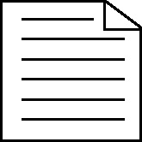

**Handout 10: Labelling a diagram – Understanding the terminology of structural analysis (D&T)**

**Task:** Select the six relevant terms from the list below and label the diagram appropriately

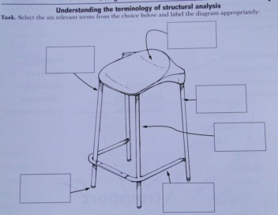

|  |  |
| --- | --- |
| direction of force | weak point |
| stay  tensional force | strut  compression force |
| shell structure | frame structure |
| area of concentrated force | area of dispersed force |
| concentrated load | weakness point |

(Adapted from material developed by Paul Drennen and Charlie Cook, D&T department, Hampstead School, Camden, London)