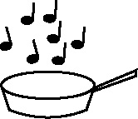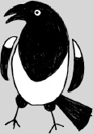

**Handout 11a: Sorting terms and generating more examples (Art)**

|  |  |  |  |
| --- | --- | --- | --- |
| **Orange** | **Red** | **Blue** | **Yellow** |
| **Green** | **Purple** | Brown |  |

|  |  |  |  |
| --- | --- | --- | --- |
| violet | azure | olive | cerise |
| rose | gold | lemon | chocolate |
| royal | fawn | emerald | cornflower |
| clover | scarlet | peach | vermilion |
| lime | honey | indigo | lilac |
| pink | lavender | cobalt | plum |
| mustard | navy | ochre | ultramarine |
| crimson | sand | grass | tangerine |
| sky | wine | cherry | burnt sienna |
| khaki | maroon | rust | denim |
| mauve | mint | sage | turquoise |

(Adapted from material produced by the Art department at Cefn Hengoed Community School, Swansea)