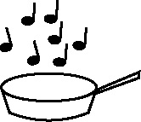

**Handout 12: Sorting terms, generating more examples and miming them (PE)**

|  |  |  |
| --- | --- | --- |
| **Key term** | **Working definition** | **Example** |
| motor skills | ability to perform certain movements with control and consistency |  |
| open motor skills | ability to perform movements affected by the environment or by others | making a tackle in football |
| closed motor skills | movements performed in stable conditions where performer has almost total control | a free throw in basketball |
| fine motor skills | involves movement of small muscle groups | flick of the wrist as the ball is released |
| gross motor skills | involves movement of large muscle groups | a sliding tackle |

(Adapted from material produced by K. Ford, PE department, Old Hall School, Rotherham)