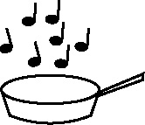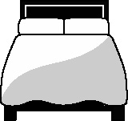

**Handout 15: Sequencing loop for cardiac cycle (PE)**

|  |  |
| --- | --- |
| vena cava | right atrium |
|  |  |
| tricuspid valve | right ventricle |
|  |  |
| pulmonary artery | lungs |

|  |  |
| --- | --- |
| pulmonary vein | left atrium |
|  |  |
| bicuspid valve | left ventricle |
|  |  |
| semi-lunar valve | aorta |

(Adapted from material from the PE department, Tupton Hall School, Chesterfield)