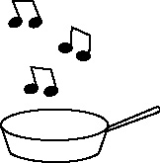

**Handout 27: Phrases for evaluation (Art, Music, English, Drama)**

|  |  |
| --- | --- |
| **When trying to describe the effect of the work:** | **When taking imaginative leaps or being tentative (uncertain) about the work:** |
| can be inferred from  connotes  creates a mood of  creates a feeling of  depicts  echoes  evokes a feeling of  evokes a mood of  gives the impression that  implies  indicates  makes me feel  portrays  recalls  reinforces  recurs  reiterates  represents  shows  signifies  suggests | I wonder what/if  It could be that  It is as if  It is almost as if  maybe  perhaps  seems to suggest |