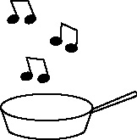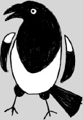

**Handout 28: Hook phrases supporting evaluation/analysis (Art, Drama, English)**

**Personal comment (first person):**

* This gives me a feeling as though …
* This makes me feel …
* This reminds me of …
* I like the way in which…
* It gives us the impression …
* We learn …

**More distanced comment (third person)**

**This/which openers**

* This shows that …
* This creates …
* This highlights …
* This implies …
* This indicates …
* This/which gives the impression …
* This gives us an insight into …
* This immediately adds …
* This quote shows that …
* This relates to the idea that …
* This evokes images of …
* This emphasises …

Which linking phrases

* … which conveys the idea that …
* … which again …

**The author/writer/ artist/designer openers (third person)**

* The author/artist shows …
* The author/artist underlines
* The author’s use of …
* The writer notes that …
* The writer conveys …
* The way the author has …
* The author builds up an/the atmosphere by …

Openers that refer to the reader

The image the reader/observer gets is …  
The reader learns …

**Tentative openers**

* It could be …
* This/it suggests …
* This is as though …
* It seems …
* It may be …
* This may also refer to …
* It is almost as if…
* … which again …

(Created by Vicky Hawking and Julia Strong)