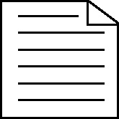 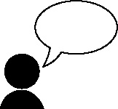 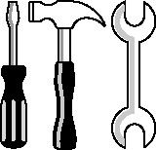

**Handout 34a: D&T product analysis exemplar text**

|  |
| --- |
| 1. **Manufacturing**   This product is made from a range of materials. The framework would have been made by line bending the plastic on a strip heater. Before it is attached to the tube and elastic head band, the metal straps are drilled and screwed to the plastic. |
| 1. **Materials**   The product is made from plastic tubing and has a head strap which is made from material, probably elastic, to fit around the head. The paper roll is held in place by a framework that is also made of plastic. |
| 1. **How is it used?**   The roll of paper, which is like a toilet roll, unravels and you blow your nose on it. When you tear off what you have used, you have a fresh sheet for next time. You don’t need to carry tissues in your pocket, as it is on your head! |
| 1. M**echanisms**   There are very few mechanisms used on the product, though there is rotary motion when the roll of paper rotates. |
| 1. **Ergonomics**   The product is made to fit on a human head by use of elastic and a round plastic tube. It does fit, so at a basic level it is ergonomically sound, although it is uncomfortable. |
| 1. E**nvironmental impact**   This product would have some impact on the environment. It is designed to be made from metal and plastic, which are recyclable. However, the elastic is not and it and the paper would have to be thrown away. It would also use a lot of energy to produce each part and transport it. |
| 1. **Maintenance**   There are very few moving parts to this product, so it would not need much repair or maintenance. However, it would need to have the roll of paper replaced when it ran out |
| 1. **Marketing**   To advertise and sell this product you would have to make it more attractive, otherwise it will be unmarketable. If it was made less bulky and offered in a range of colours to suit different types of people, it would be easier to sell. |
| 1. **Improvements**   This product is very impractical and therefore a number of major improvements need to be made. The roll of paper gets in the eyes so it needs to be held out of the way. Moreover, if you wore it out in the rain, the paper would become soggy and therefore would have to be protected from the elements. Finally, it looks both uncomfortable and unattractive so a significant redesign is needed. |

(Adapted by Julia Strong from work done by Jo Tyrrell-Baldwin from Portslade Aldridge Community Academy, Brighton)