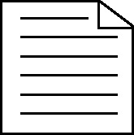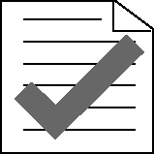 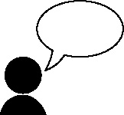 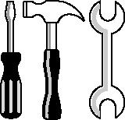

**Handout 34b: Evaluating my Mega Bubble Blowing Machine (MBBM)**

*For my controlled assessment, I designed and made an MBBM for children and men of all ages. My machine provides essential bubble blowing in a mega way, using SMART materials to provide structure and support for the bubbles.*

*It has been designed to ergonomically fit into the user’s hand, with a soft-grip palm support for added comfort and user safety. It is lightweight and easy to carry and can easily be folded away for storage. In addition, the appearance of the MBBM is modern in shape but has a contemporary feel and touch.*

*The product can be used both indoors and outside due to hardwearing and robust materials that were chosen as a result of extensive testing of a range of possible materials.*

*To keep costs low, I would use computer-aided design and manufacture, possibly a 3D printer and ABS plastic. The cost for each product will be between £10 and £15, which, through my survey of users, is a price that consumers felt was reasonable.*

*The prototype I made was thoroughly tested by a range of possible users. From their feedback, I made a number of modifications including thickening the handle and including a non-slip surface to the handle.*

*In conclusion, I believe I have fulfilled the needs of my clients as specified in the design brief.*

(Adapted from the work of the Technology department, Graham School, Scarborough)