   **Handout 36a: Advantages and disadvantages of solar energy for heating water**

*The picture shows one type of solar water heater. Water from the tank is slowly pumped through copper pipes inside the solar panel where the water is heated by energy from the Sun.*

*Each day the average European family uses 100 kg of hot water. It takes 16 800 000 J of energy to heat this mass of water to the correct temperature.*

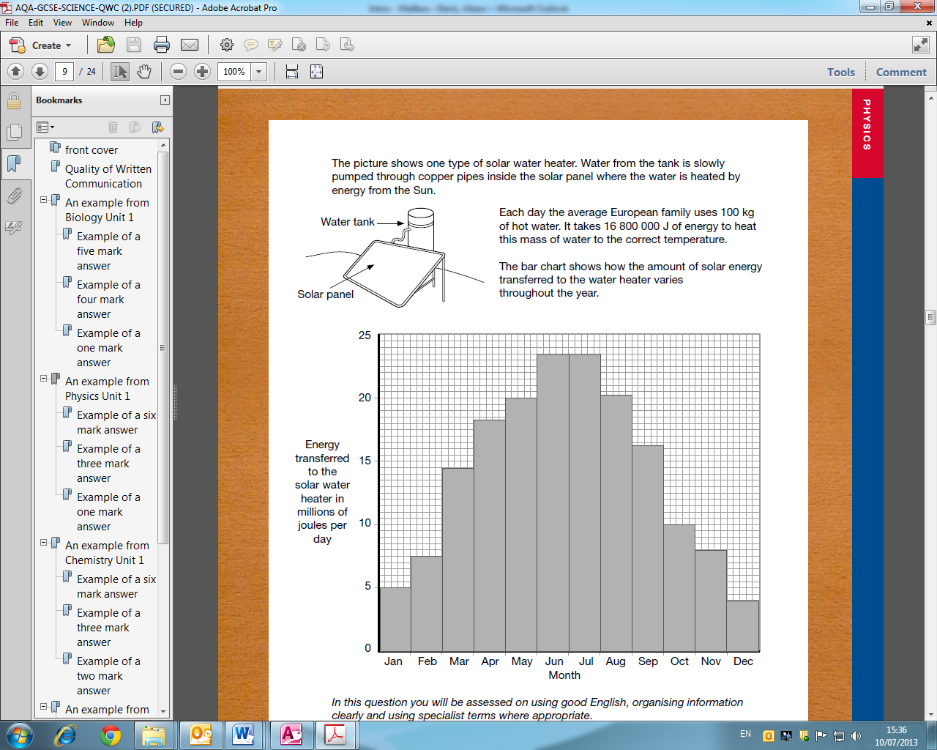

*The bar chart shows how the amount of solar energy transferred to the water heater varies throughout the year.*



*In this question you will be assessed on using good English, organizing information clearly and using specialist terms where appropriate*

*The water in the tank could be heated by using an electric immersion heater. Outline the advantages and disadvantages of using solar energy to heat the water rather than using an electric immersion heater.*

(From AQA’s *Guidance on Quality of Written Communication (Science)* document)