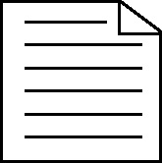

**Handout 38b: Selecting relevant information cards for the Great Fire of London question**

|  |  |
| --- | --- |
| Water supplies were unusually low in 1666 | Officials did not believe it was going to spread and took no action when it started |
| Houses in London were built very close together | Someone started a fire in Pudding Lane |
| Throughout London, heating and lighting were provided by fire | Houses fires were common and often extinguished by demolishing surrounding property |
| The mayor allegedly said: ‘Pish! A woman might piss it out,’ and refused to order the surrounding property to be demolished | The wind on the day of the fire was very strong |
| Most buildings were made of wood | Fire-fighting equipment was not good enough to cope with a large fire |