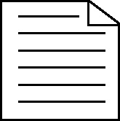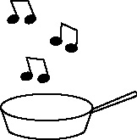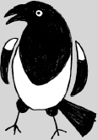

**Handout 39a: Formal letter writing (and speaking)**

|  |  |  |  |
| --- | --- | --- | --- |
| Appropriate for a formal letter | **What I know to begin with** (jot the appropriate phrases here in French) | **What I now know** (jot any additional appropriate phrases here in French) | **What more do I need to know?** (jot down in English the formal phrases you think you might need that you don’t know how to express in French) |
| Starting |  |  |  |
| Thanking |  |  |  |
| Ordering |  |  |  |
| Sending |  |  |  |
| Asking information |  |  |  |
| Complaining |  |  |  |
| Finishing |  |  |  |