 **Handout 4a: Text map and exemplar text for Fox facts**

**Text map for Fox Facts**

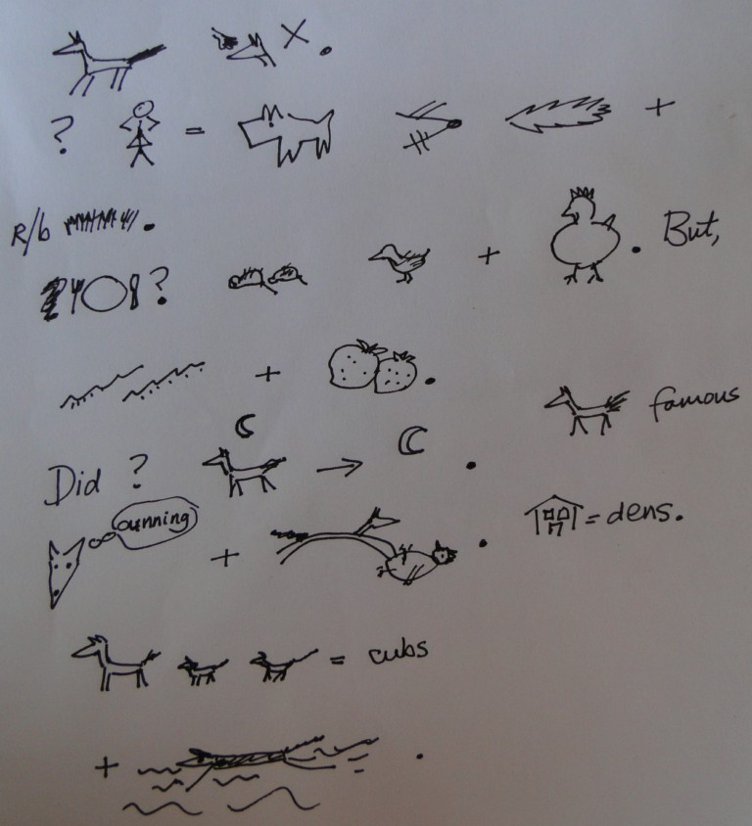



**Fox Facts**

Foxes are not pets.

What are they like? They are elegant dog-like creatures with sharp noses, bushy tails and reddish-brown fur …

What do they eat? They eat small furry animals, feathery birds and they are very fond of tasty plump chickens too. But they also eat squiggly insects and juicy berries.

Did you know that foxes are nocturnal? That means they come out at night. Foxes are famous for being cunning and pouncing on their prey. Their homes are called dens. Their babies are called cubs.  
 And they can swim!