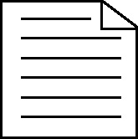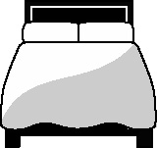 **Handout 5b: Revision frame for the human skeleton (physical education)**

|  |  |  |
| --- | --- | --- |
| **What do I know?** Jot down the key points for the following: | **What extra do I need to add?** | **Tasks to test myself on** |
| Functions:   * ... * ... * ... * ... * ...   Classification   * ... * ... * ... * ...   Anatomy of bone   * ... * ... * ... * ... * ... * ...   Growth of bone   * ... * ... * ... |  | 1. Label the diagram of a skeleton:  * bones   – classification   1. Label diagram of structure of bone |

(Adapted by Julia Strong from the work of A. Watson and D. Jane, PE department, Tupton Hill School, Chesterfield)

[handout ends]