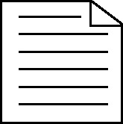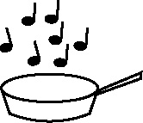

**Handout 6: Never-heard-the-word grid - blank template**

Listen carefully while the words below are read to you and used in context – then fill in the appropriate column.   
**Warning:** Beware of tricky words that have a very different everyday meaning from their meaning in a maths context. These tricky words are **highlighted** and marked with an **asterisk**\*.

|  |  |  |  |
| --- | --- | --- | --- |
| **Key words** | **Never heard the word before** | **Heard it but not sure of its meaning** | **Know what it means and can explain in context – jot down your ideas here** |
|  |  |  |  |
|  |  |  |  |
|  |  |  |  |
|  |  |  |  |
|  |  |  |  |
|  |  |  |  |
|  |  |  |  |
|  |  |  |  |
|  |  |  |  |
|  |  |  |  |
|  |  |  |  |
|  |  |  |  |
|  |  |  |  |
|  |  |  |  |
|  |  |  |  |
|  |  |  |  |
|  |  |  |  |
|  |  |  |  |
|  |  |  |  |
|  |  |  |  |