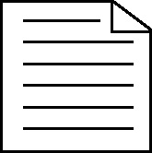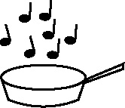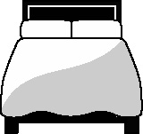

**Handout 7b: Clumping activities to activate prior learning**

|  |  |  |  |
| --- | --- | --- | --- |
| **Words related to circular shapes** | **Words related to multi-sided shapes (more than 3 sides)** | **Words related to triangles** | **General 2D/3D words** |
| radius | square | triangular | regular |
| diameter | rectangle | three-sided | edge |
| circumference | kite | isosceles | face |
| concentric | parallelogram | equilateral | surface |
| spherical | rhombus | scalene | angle |
| cylindrical | oblong | congruent | centre |
| curved | pentagon | pyramid | right angle |
| semi-circle | polygon |  | line |