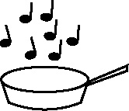 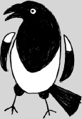

**Handout 9a: Generating related vocabulary (Music)**

|  |  |  |
| --- | --- | --- |
| **Key musical terms** | **Opening Ravel’s *Bolero*** | **Opening Dukas’ *The Sorcerer’s Apprentice*** |
| tempo |  |  |
| rhythm |  |  |
| mood |  |  |
| melody |  |  |
| texture |  |  |
| pitch |  |  |
| dynamics |  |  |