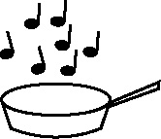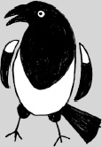

**Handout 9c: Matching related vocabulary to key terms (Art)**

|  |  |  |  |  |
| --- | --- | --- | --- | --- |
| **Artist’s intention** | exaggerate  express | distort  explore | recreate  evoke | reflect  suggest |
| **Mood** | happy  frightening | sad  awesome | haunting  entertaining | evocative  nostalgic |
| **Form/ composition** | balanced  design | symmetrical  angular | arrangement  curved | composition  foreground |
| **Use of tone, colour, texture** | vivid  clashing | sombre  pastel | bright  matching | dull  rough |
| **Style** | technique  realistic | abstract  surrealistic | cubist  pop art | impressionist  graphic |
| **Medium** | watercolour  clay | chalk  found objects | charcoal  oils | textile  video camera |
| **Technique** | shading  printing | weaving  rubbing | sculpting  dyeing | blending  drawing |

(Adapted from material developed by the Art department at Hampstead School, Camden, London)