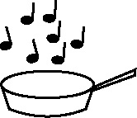

**Handout 9d: Matching related vocabulary to key terms (Music)**

|  |  |  |  |
| --- | --- | --- | --- |
| **Dynamic** | acoustic | bass line | chorus |
| **Electronic/digital** | choral | cyclical | descant |
| **Melody** | harmonic | higher | improvisation |
| **Mood** | interlude | linear | lower |
| **Pitch** | major | metre | minor |
| **Rhythm** | microphone | multi-track | notation |
| **Structure** | phrasing | pulse | repetition |
| **Tempo** | rondo | stereo | synthesizer |
| **Texture** | timbral | timbre | tremelo |